

PROJECT OF CSE 326

SYNOPSIS ON THE PROJECT

FLIGHT RESERVATION SYSTEM

SUBMITTED TO:

SHABNAM

FACULTY OF CSE 326

SUBMITTED BY:

ANMOL RAJ ROLL NO. 25 REG. NO. 11908117

VIKRAMADITYA KEHAR ROLL NO. 34 REG. NO. 11906718

ARPIT GARG ROLL NO. 07 REG. NO. 11905571

SECTION: K19RH

Here, we are making a project on flight reservation management using HTML and CSS. Talking about the blueprint we are making a landing page and connected pages through it listed as below

1. Home
2. Gallery
3. Plan trip
4. Contact us

**1. HOME**

At the top, we have kept home, gallery, plan trip, Contact us, with the help of CSS we use hover and home as active as a white background and black text else other option backgrounds is transparent and text color as the white, the transition is 0.6 ease for a smooth transition effect. Then after another div is made by us for the styling of the main topic with the font-size 70px with white font-color. Then after 3 buttons include first for Booking the ticket other two for login and sign in, and transition effect is use as similar 0.6s ease. On the basis of the appearance, the book ticket looks just in contrast to the login and the sign-in option for maintaining the difference and their transition is also opposite to each other as book ticket is the black font in color and white background whereas the login and sign in is using white color and transparent background and there transition is book ticket as white and transparent background and the sign in login background is white and the text is black for hover.

Let’s now discuss the three-button at the bottom of the title book ticket transfer you to another page linked for **Book Ticket** which is mainly based on the booking form of the flight here we first use a div and create as the class as booking form box in that another div to a class created for the radio button and then as three input as radio taken in another class as a round trip, one way and multi-city and round trip being a common choice we checked that radio automatically for making page user friendly after that let’s talk about its CSS  part as after normal body background in the class of booking form max-width is provided with border with a solid and margin to the center for good looking even page in radio button class margin is given to all direction for the clean interface for better experience border-radius as 50% and display as inline-block with a transition of 0.5s then in HTML new class created with div for booking form detail with label Flying from-to in inputs as text, the departing and returning input as date type two number input for the number of the passenger as adult and children and then the new label for the class as business class, economy class, and First class in the select as three option, then a button for Show Flight as per booking label CSS use for font size and color then after all box-shadow changes as none and background as transparent then with the help of bootstrap cdn webkit-appearence button is none and for calendar background transparent and little bit hover effect on button for the styling.

For the **Login** **page**, we try a different approach as a login page is the simple looking and making pages as to create a form and a button for completion that’s why we try to create a little attractive login page as animation a little. Let’s start with a heading Welcome back as login mean people are signed up before and he came again that’s why welcome back as a heading. the n with different class name classic input as a text for user name and input password as password the forgot password as a link but using # checkbox for remember me button for login and the heading with a written new member and another as a sign-in link to the sign-in page. Now the difficult part of the login in is animation through the CSS as the left side in the form and right is filled by the image using animation as left of animation-delay as 1s animation duration, fill mode, the name is left section for right flex and transition is used, then normal heading padding, width and all are used for the beautification of the form and the animation for each input begin as a delay at the difference of the 0.1 s difference then keyframe of the move(name of animation) is opacity 0 to 1 in y-direction used in input and left section opacity 0 to 1 and width 0 to 440 px

Similarly, the animation is the same for **sign-in** and form include Welcome name, email, and username as input as text and password with a checkbox with remember me with sign-in and the Having Account to login button which direct to login.

**2. GALLERY**

The idea behind the Gallery to show the companies and their facility of the flight so there we create 8 pictures with the quality of the brand for the clarity of choosing with a great interface as the pointer point to the image the quality come up and show using transition. Now or the coding blueprint the gallery, same as home header includes the list of option as home gallery plan trip and contact us in the all except gallery is having transparent background and the white-colored font whereas gallery having black colored text and white background to show the presence on the page after that a div created for a box then the image another div with a class created then the image of the gallery with heading and using paragraph give the name of the company and the quality provided by them. Similarly, 8 boxes created for the 8 company with the same class name for heading the hover effect and all settlement as the home copied after the box class box background, box-sizing, margin given the in image box class overflow is hidden, the image in this taking transform of 2s then hover on the scale (1,2), the transition followed by the details of companies is 0.5 transform in scale Y and using hover in which the scale Y which is 0 is covering to 1, for a better user interface.

**3. PLAN TRIP**

The idea behind these that room booking the place using card type view as it is trending topic that’s why we thought to take it, it also helps to show us a new technique to place thing in card form, same as home and gallery the heading this time plan trip will be active then after using a heading tag for the heading then using few div with a class as list prepare three deals with button book it. In CSS first all CSS code fort the heading then after classes background color and the border is making ready the after pricing font size managing then the code for the card making 3 deals, then the button and its hover effect, this little bit big to write but easy in looking to the page without scroll.

**4. CONTACT US**

Here in the contact-us area most of the thing remaining common and to make in little attractive we add a window type design which took a ton of coding in CSS, mean many div and class for the single circle and many more to give it a window opened look many coding done but the basic structure is the input name, email, contact number, and the message all in input as text type the two buttons for cancel and send using hover at both buttons for a clean-looking page and also providing the contact info like a contact number for a complete contact us.

**Sample Screenshots of few pages attached below :-**

**Contact Us**

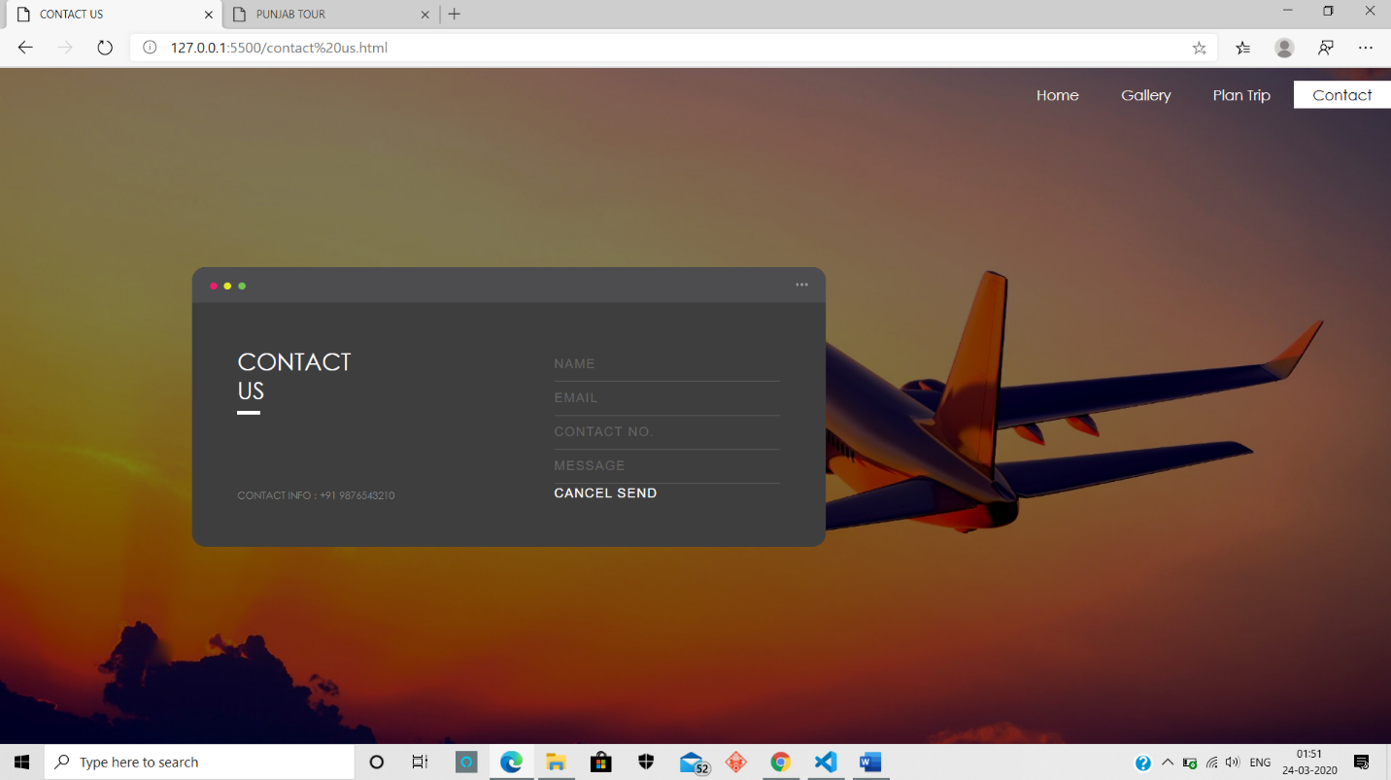

**Home:**

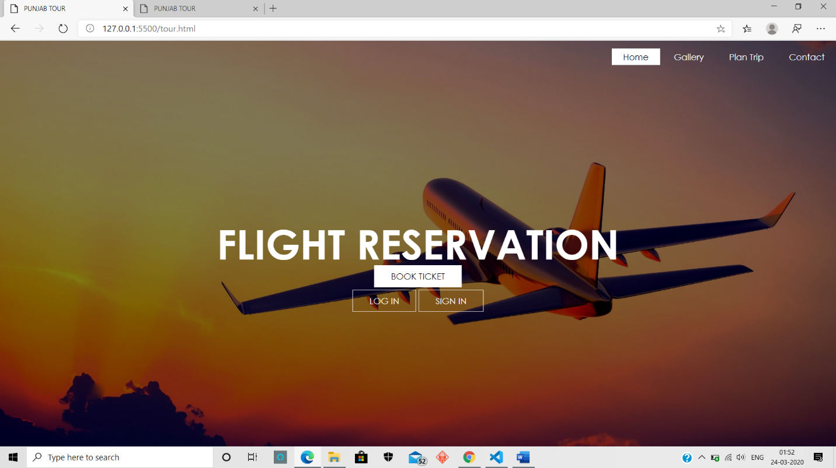

**That’s all from our side, Thank you.**

* **Anmol Raj Roll no. 25 Reg. No. 11908117**
* **Vikramaditya Kehar Roll no. 34 Reg. No. 11906718**
* **Arpit Garg Roll no. 07 Reg. No. 11905571**